**Introduction**

One can think of valuation as a matter of accounting. However, accounting for value is typically incomplete. Good accounting minimizes speculation attributable to accounting (in the short-run) so that one can focus his or her efforts on challenging speculation in the market price.

**The Game of Investing**

Discard the idea of “intrinsic value”. Even though valuation models specify a number, “value”, as the output of the valuation process, it is not helpful to think of a notion of true “intrinsic value”.

Graham and Dodd We are concerned with the intrinsic value of the security and more particularly with the discovery of the discrepancies between intrinsic value and price. We must recognize, however, that intrinsic value is an elusive concept. In general terms it is understood to be that value which is justified by the facts, e.g., the assets, earnings, dividends, definite prospects – as distinct, let us say, from market quotations established by artificial manipulation or distorted by psychological excesses. But it is a great mistake to imagine that intrinsic value is as definite and as determinable as is the market price.

Valuation models should not be used for determining a value but rather as a mechanism for gauging uncertainty about value. Fundamental analysis brings information to the cause of reducing our uncertainty, but not eliminating the uncertainly that inevitably accompanies risky investing.

Accounting identifies where our uncertainty lies provided that the accounting involves numbers that we are fairly secure about – rendering value justified by the facts. Accounting does not render the complete value but does tell us where our uncertainty about the market price lies and where we run the risk of paying too much – often this is captured by uncertainty about growth.

Equity investing is not a game against nature, but against other investors. Valuation models should be used to understand how an investor thinks differently from other investors in the market. Thus the wright question to ask of a model is not what the “right” value is but rather whether the model can help the investor understand the perceptions of other investors embedded in the market price. It is our job then to challenge those perceptions. It remains to take the accounting further to discover the growth forecast behind the valuation and with this growth forecast decide whether to accept or reject the market price that we are being offered.

**Challenging Speculation in the Market Price**

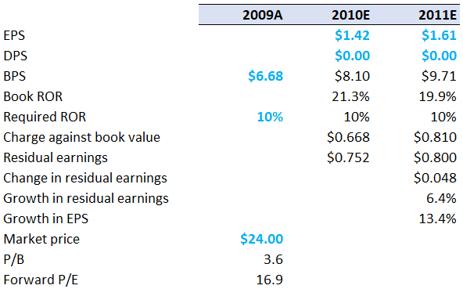One might question whether GAAP earnings in these forecasts are the appropriate accounting for the task. One might question whether the sell-side analysts’ forecasts provide a sound anchor – analyst can be overly optimistic in bull markets and conversely more pessimistic in bear markets. It is best practice to do your own independent accounting to anchor on what “you” know.

asdf